**SUMMER MASTERCLASSES 2023**

**APPLICATION FORM**

Student's name ..........................................................................................................................

Address....................................................................................................................................... ........................................................................................................................................................................................................................................................................................................Postcode ...................................................

Contact telephone number(s) ...................................................................................................

Email address ............................................................................................................................

Date of Birth .......... / .......... / ..........

Any medical conditions, injuries or allergies .............................................................................

............................................................................................................................................................................................................................................................................................................................................................................................................................................................

Are you happy for us/visiting companies to use images/recordings of your child for promotional purposes as follows (please tick the appropriate box)

On paper documents / advertising materials

Yes [ ] No [ ]

On our/their website / social media sites (with no name)

Yes [ ] No [ ]

[ ] I confirm that I have read, understood and agreed to the fees terms and conditions overleaf.

Signed ........................................................................................

Please indicate which workshop(s) you would like to book below:

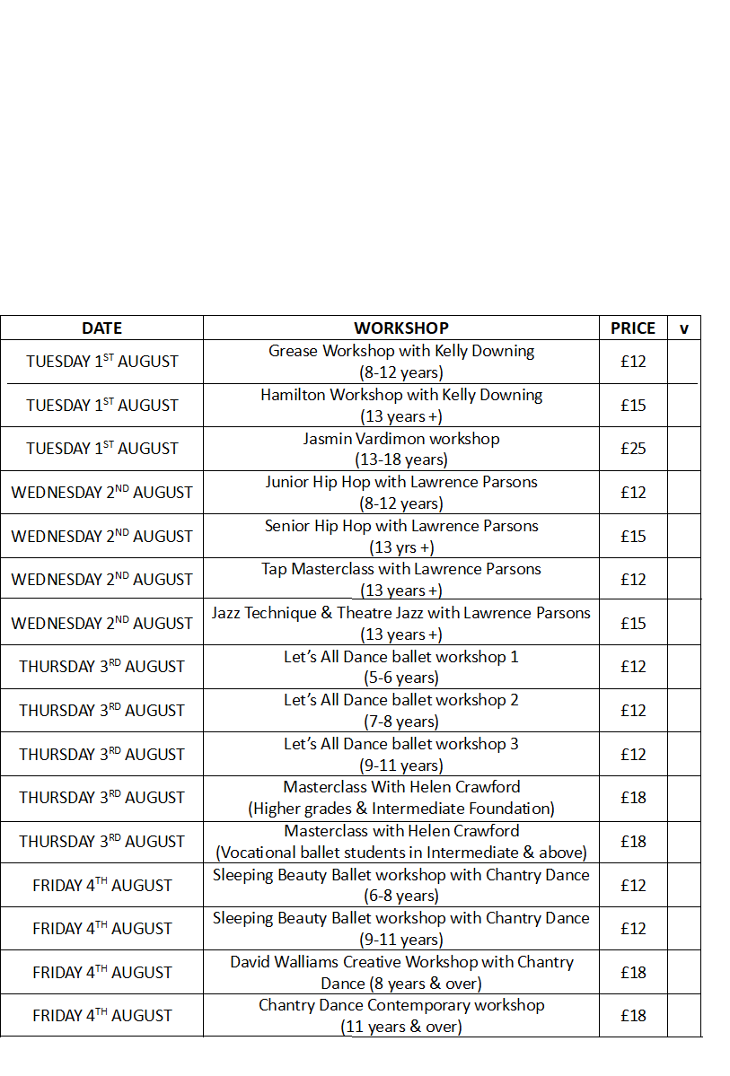

Prices per workshop as shown

10% Sibling discount &

10% discount for attendance to 3 masterclasses or more

Invoices will be sent out with confirmation of your booking

***Fees Terms & Conditions***

*Fees are payable in advance on confirmation of your booking and are non-refundable. Due to restricted spaces in each workshop any unpaid fees may result in a student forfeiting their place. If we or a visiting company have to cancel a workshop for any reason a full refund will be given.*